MECHANICAL ANALYSIS
REMINGTON-AGENSTEIN SCIENCE BUILDING

MISSOURI WESTERN STATE UNIVERSITY
ST. JOSEPH, MO

August 25, 2017

APPENDIX

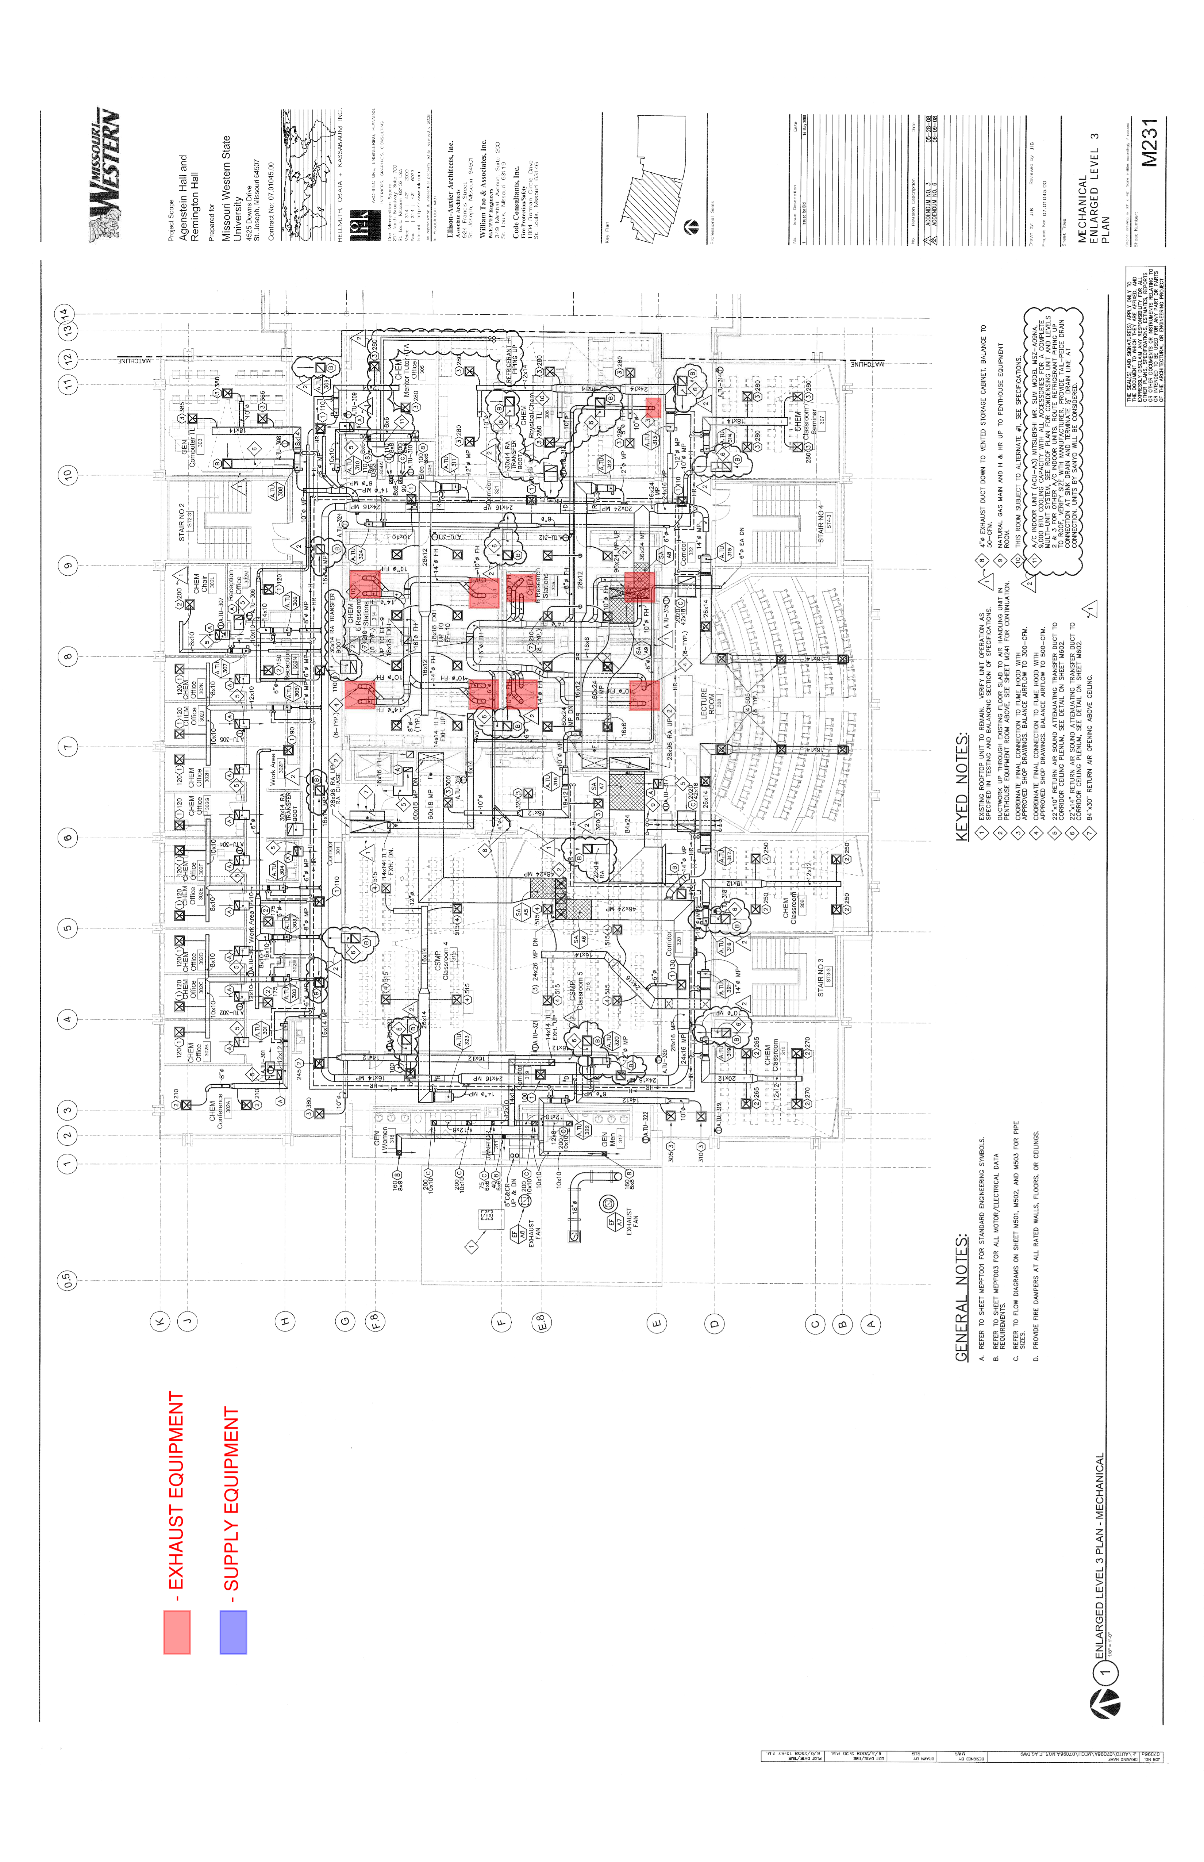
S
